

Connected Vehicle Electronics

**Concept of Operations**

**(ConOps)**

**Stowable Steering Wheel**

**Version 0.12**

**2/11/2020**

Printed Copies are UNcontrolled

***FORD MOTOR COMPANY***

***CONFIDENTIAL***

**The information contained in this document is Proprietary to Ford Motor Company. Disclosure or distribution to unauthorized persons is strictly prohibited.**

**Copyright, Ó 2016 Ford Motor Company**

**Confidential and Proprietary – Ford Motor Company**

This document contains information developed and accumulated by and for FORD MOTOR COMPANY. As such, it is a proprietary document, which, if disseminated to unauthorized persons, would provide others with restricted information, data, or procedures not otherwise available, exposing the FORD MOTOR COMPANY to potential harm.

Employees and suppliers having custody of this specification or authorized to use it must be cognizant of its proprietary nature and ensure that the information herein is not made available to unauthorized persons.

FORD MOTOR COMPANY reserves the right to protect this work as an unpublished copyrighted work in the event of an inadvertent or deliberate unauthorized publication. FORD MOTOR COMPANY also reserves its rights under copyright laws to protect this work as a published work.

This document or portions thereof shall not be distributed outside FORD MOTOR COMPANY without prior written consent. Refer all questions concerning disclosure to the author(s) or to the Forward Model Radio Section, Ford Motor Company.

# 

Contents

1 Introduction 6

1.1 Audience 6

1.2 Feature Vision 6

2 Feature Analysis 7

2.1 Motivation 7

2.2 Background Study 7

2.3 System (and customer) Use Cases 7

2.3.1 Minimum Viable Product 7

2.3.2 Nice to Have 8

2.3.3 Use cases 8

2.3.4 Feature states and user settings 13

2.4 Failure Mode Scenarios 13

2.5 Boundary Diagram 15

3 Solution Evaluation 16

3.1 Solution Options 16

3.2 Solution Recommendation 16

3.3 Assumptions 16

3.4 Constraints 17

3.5 Dependencies 17

3.6 Scope 17

3.6.1 In Scope: 17

3.6.2 Out of Scope: 17

4 Design Analysis of the Proposed Solution 18

4.1 Functional System Architecture 18

4.1.1 Ford Pass Functions list: 18

4.1.2 Ford Cloud/SDN 18

4.1.3 TCU Functions 18

4.1.4 ECG Functions list 18

4.1.5 SYNC Functions 19

4.1.5.1 SSW App 19

4.1.5.2 HMI 21

4.2 Functional Interface Analysis 21

4.2.1 Ford pass <-> SDN 21

4.2.2 TCU <-> ECG 21

4.2.3 SYNC <-> ECG 21

4.2.4 ECG <-> Ford Cloud 21

4.3 Data Usage Requirements 21

4.4 IVIC memory and processing Estimation 21

4.5 Message Sequence Diagram 21

4.6 System Functional Requirements 25

4.6.1 General system requirements 25

4.6.2 FordPass 25

4.6.3 Ford Cloud 25

4.6.4 TCU 25

4.6.5 ECG 25

4.6.6 SYNC 25

4.6.7 IPC 26

4.6.8 PSM Module 26

4.6.9 DSM 26

4.7 Managing potential feature interactions 26

4.7.1 Autosave 26

4.7.2 Power Pitch Feature 26

4.7.3 Easy exit/entrance 26

4.8 Impact Analysis Summary on FNV2.0 IVIC Modules 28

5 Glossary 29

6 References 30

7 Document Reviews 31

Revision History

|  |  |  |  |  |
| --- | --- | --- | --- | --- |
| **Revision** | **Author** | **Description** | **Sections Affected** | **Release Date** |
| V0.01 | Hanan Ahmed [Hahmed6@Ford.com](mailto:Hahmed6@Ford.com) | First draft |  | 07/23/2020 |
| V0.02 |  | Updated use cases based on review with FO, Aug 13th. |  | 08/20/2020 |
| V0.03 |  | Updated use cases based on review with FO, Aug 20th. |  | 08/21/2020 |
| V0.04 |  | Editorial |  | 08/25/2020 |
| V0.05 |  | Sequence diagram update, added open issues |  | 09/01/2020 |
| V0.06 |  | Editorial |  | 09/02/2020 |
| V0.07 |  | Added EM interactions | Failure mode scenarios & open issues | 09/08/2020 |
| V0.08 |  | Added DSM, Updated flows, interactions with other features |  | 10/26/2020 |
| V0.09 |  | Updated DSM & SSW modules roles per discussion with the feature owner |  | 11/12/2020 |
| V0.10 |  | Updates for ASIL-B rating, changes to tray deployment steps |  | 12/04/2020 |
| V0.11 | Khaled Bahar | Replaced SSW module with PSM module and reflected all necessary changes | All | 02/09/2021 |
| V0.12 |  | Updated after review with FuSa | All | 2/11/2021 |
| V0.13 |  | Minor changes | Section 3 | 2/19/2021 |

# 

# Introduction

The objective of the concept of operation (ConOps) document is to perform an initial technical analysis of the new vehicle features, evaluate solution options and provide design and solution recommendation. The technical analysis includes functional level software and interface impact analysis.

The technical analysis performed during this phase would enable the development teams to estimate the design and implementation efforts. The information can also be leveraged for developing detailed feature specifications

The focus of the technical analysis in this document is the Stowable Steering wheel with deployable work surface

1.1 Audience

Below are departments identified as the stakeholders of this feature, and can be consulted for input during the Pre-PS feature analysis

* CVP&P Feature Owner
* EESE Feature Owner
* FNV2.0 Platform Development
* Infotainment SPSS author
* …..
* …..

1.2 Feature Vision

The vision of stowable steering wheel with deployable work surface is to enable customers to make use of their fragmented time making the most of the Stationary Time spent waiting inside the vehicle to be productive and to keep pace with the world, or simply allow them to enjoy a piece of me-time or manage business needs.

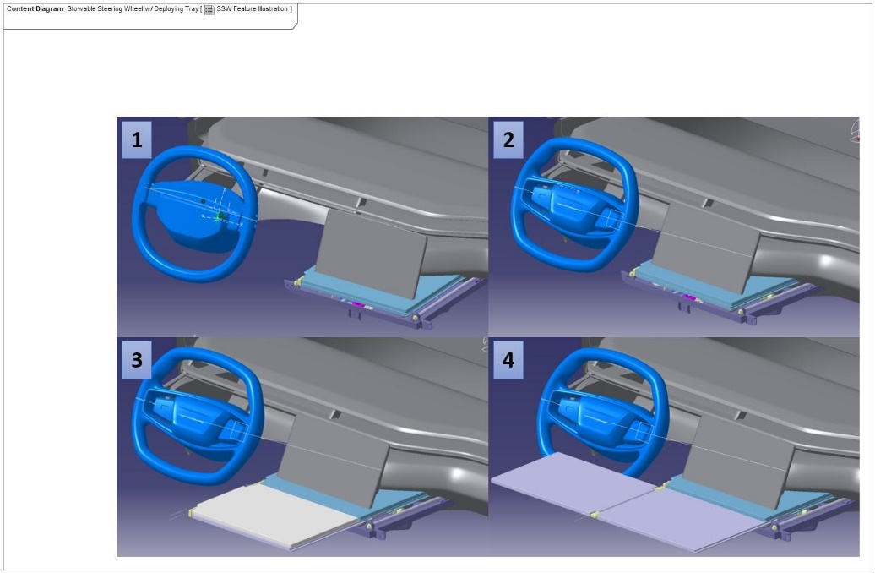

**Figure (1); Stowable Steering wheel and Extended Tray**

# Feature Analysis

2.1 Motivation

The main motivation of this feature is to meet customers’ needs to balance family and work responsibilities by utilizing the time spent waiting inside the vehicle to be productive, relax or simply do what they want.

2.2 Background Study

Other OEMs do not have similar products but there are multiple aftermarket solutions of trays that can be attached to the steering wheel or other parts of the vehicle. The general reviews are not positive because of quality issues, the fit and the damage some may cause to the vehicle’s interior.

## System (and customer) Use Cases

### 2.3.1 Minimum Viable Product

As a(n) <actor> I want to …….……. action ………………. so that……………<proposed value>

|  |  |  |
| --- | --- | --- |
| Customer / Driver | Move the steering column and steering wheel as far away from me as possible as quickly as possible via a hard or soft push button interaction. | I can have more space and freedom of movement in < 6 seconds. |
| Customer / Driver | Use a tray table that partially deploys in the driver’s seat area as quickly as possible via a soft push button interaction. | I can be productive and have a flat work surface in < 6 seconds. |
| Customer / Driver | Easily return to the vehicle driving state from either of the aforementioned states as quickly as possible via a hard or soft push button interaction. | I can easily use my vehicle’s primary purpose of mobility in < 6 seconds. |
| Customer / Driver | Easily move between any current feature state to any chosen feature state as quickly as possible via a hard or soft push button interaction. | I can get to the feature mode I want in < 6 seconds. |
| Customer / Driver | Have easy-to-understand operation and status indication of each state near the hard or soft push button interaction location. | I can understand what state I am in and how to return to vehicle driving state |
| OEM | Disable the airbag, | I can protect the customer from unsafe feature operation states |

**Table (1); Minimum Viable Product**

### Nice to Have

As a(n) <actor> I want to …….……. action ………………. so that……………<proposed value>

|  |  |  |
| --- | --- | --- |
| Customer / Driver | Have the ability to halt the steering column, wheel or tray table movements at any time by pushing/pulling using my hands or any object dislodged within the tray mechanism, etc. | I can feel safe and in control of the feature. |
| Customer / Driver | User selectable intelligence to easily adjust my posture and position with respect to the tray table’s position via seat movement. | I can have good ergonomics and comfort while using the tray table |
| Customer / Driver | Initiate each feature state as quickly as possible | I do not have to wait an unreasonable amount of time to use the feature |
| Customer / Driver | Have the seat movement return to the same position profile as when I last used the feature | I do not have to duplicate steps and waste time to use the feature |

**Table (2); Nice to Have features (later phases)**

### Use cases

Deploy Steering Column

|  |  |  |
| --- | --- | --- |
| **Actors** |  | User |
| **Subject** |  | Stowable Steering Wheel w/ Deploying Tray |
| **Description** |  | The Steering Column is returned to a drivable state only after the preconditions are met. |
| **Preconditions** | PreC1 | Passive Restraints Enabled |
| PreC2 | Vehicle Locomotion Enabled |
| PreC3 | Vehicle Parked |
|  |  | Steering Column moves to a drivable position in the allotted time. |

Deploy Work Surface

|  |  |  |
| --- | --- | --- |
| **Actors** |  | User |
| **Subject** |  | Stowable Steering Wheel w/ Deploying Tray |
| **Description** |  | Deploy the Tray Table to serve as a working surface. |
| **Preconditions** | PreC1 | Passive Restraints Disabled |
| PreC2 | Vehicle Locomotion Disabled |
| PreC3 | Vehicle Parked |

Enter non-drivable Mode

|  |  |  |
| --- | --- | --- |
| **Actors** |  | System |
| **Subject** |  | Stowable Steering Wheel w/ Deploying Tray |
| **Description** |  | non-drivable Mode prevents Vehicle Locomotion and is allowed when preconditions are met. |
| **Preconditions** | PreC1 | No Faults or Disallowed Conditions preventing disabling Passive Restraints |
| PreC2 | No Faults or Disallowed Conditions preventing non-Motive Mode |
| PreC3 | Vehicle Parked |
|  | Steering wheel stowed or tray table deployed |
| **Main Flow Description** |  | Disable vehicle locomotion or vehicle cannot be driven. |

Gain Space and Freedom of Movement

|  |  |  |
| --- | --- | --- |
| **Actors** |  | User |
| **Subject** |  | Stowable Steering Wheel w/ Deploying Tray |
| **Description** |  |  |
| **Preconditions** | PreC1 | Appropriate Vehicle Status signals indicate the vehicle is parked and not moving. |
| **Triggers** | T1 | User initiates a request to either Stow or Deploy Steering Column. |
| **Main Flow Description** |  | Driver stows Steering Column, relaxes after gaining space and freedom of movement and deploys Steering Column once done and ready to drive vehicle. |
| **Main Flow** | M1 | Driver requests to stow Steering Column. |
| M2 | SSW requests to inhibit Passive Restraints. |
| M3 | SSW requests to inhibit Vehicle Locomotion. |
| M4 | SSW stows Steering Column. |
| M5 | SSW requests Driver Seat to move to predefined position stored by Personal Portable Profiles feature. |
| M6 | Driver requests to deploy Steering Column. |
| M7 | SSW requests Driver Seat to move to driving position stored by Personal Portable Profiles feature. |
| M8 | SSW deploys Steering Column. |
| M9 | SSW requests to enable Passive Restraints. |
| M10 | SSW requests to enable Vehicle Locomotion. |
| M11 | Driver can cancel deployment or stowing operations at any time. |
| **Alternative Flow Description** |  | Driver can cancel deployment or stowing operations at any time. |
| **Exceptional Flow Description** |  | Fail to Inhibit Passive Restraints or Vehicle Locomotion. |
| **Exceptional Flow Description** |  | Fail to deploy Steering Column or move Driver Seat to Driving Position. |
| **Exceptional Flow Steps** | E1 | If failure to deploy Steering Column or move Driver Seat to Driving Position then do not Enable Passive Restraint or Vehicle Locomotion. Inform Driver via HMI of condition and inform Driver what steps are available to return vehicle to a drivable state. |
| E2 | If failure to Inhibit Passive Restraints or Vehicle Locomotion then do not deploy SSW feature. Inform Driver via HMI what steps are available to correct failure if any. |
| **Postconditions** | PostC1 | Vehicle Steering Column, Driver Seat are in driving positions. |

Move Seat

|  |  |  |
| --- | --- | --- |
| **Actors** |  | User |
| **Subject** |  | Stowable Steering Wheel w/ Deploying Tray |
| **Description** |  | The Driver Seat is moved to support the different Use Cases of the Feature. |
| **Preconditions** | PreC1 | Passive Restraints Disabled |
| PreC2 | Vehicle Locomotion Disabled |
| PreC3 | Vehicle Parked |
| **Main Flow Description** |  | Seat moves to assigned position in the allotted time. |

Program Seat Memory

|  |  |  |
| --- | --- | --- |
| **Actors** |  |  |
| **Subject** |  | Stowable Steering Wheel w/ Deploying Tray |
| **Description** |  |  |
| **Preconditions** |  |  |

Stow Steering Column

|  |  |  |
| --- | --- | --- |
| **Actors** |  | User |
| **Subject** |  | Stowable Steering Wheel w/ Deploying Tray |
| **Description** |  | The Steering Column will only stow when the pre-conditions are met. |
| **Preconditions** | PreC1 | Passive Restraints Disabled |
| PreC2 | Vehicle Locomotion Disabled |
| PreC3 | Vehicle Parked |
| **Main Flow Description** |  | Stow Steering Column to support feature use in the allotted time. |

Stow Work Surface

|  |  |  |
| --- | --- | --- |
| **Actors** |  | User |
| **Subject** |  | Stowable Steering Wheel w/ Deploying Tray |
| **Description** |  | Stow Work Surface stows the Tray Table when the user is finished using it. |
| **Preconditions** | PreC1 | Tray Table Deployed |

Use Work State Tray Table

|  |  |  |
| --- | --- | --- |
| **Actors** |  | User |
| **Subject** |  | Stowable Steering Wheel w/ Deploying Tray |
| **Description** |  |  |
| **Preconditions** | PreC1 | Appropriate Vehicle Status signals indicate the vehicle is parked and not moving. |
| **Triggers** | T1 | User initiates a request to either Deploy or Stow Work State Tray Table. |
| **Main Flow Description** |  | Driver deploys Work State Tray, uses Tray Table and stows Tray once done. |
| **Main Flow** | M1 | Driver requests to deploy Work State Tray Table. |
| M2 | SSW requests to inhibit Passive Restraints. |
| M3 | SSW requests to inhibit Vehicle Locomotion. |
| M4 | SSW stows Steering Column. |
| M5 | SSW requests Driver Seat to move to predefined position stored by Personal Portable Profiles feature. |
| M6 | SSW deploys Tray Table. |
| M7 | Driver uses Tray Table. |
| M8 | Driver requests to stow Work State Tray Table. |
| M9 | SSW stows Tray Table. |
| M10 | SSW requests Driver Seat to move to driving position stored by Personal Portable Profiles feature. |
| M11 | SSW deploys Steering Column. |
| M12 | SSW requests to enable Vehicle Locomotion. |
| M13 | SSW requests to enable Passive Restraints. |
| **Alternative Flow Description** |  | Driver can cancel deployment or stowing operations at any time. |
| **Exceptional Flow Description** |  | Fail to Inhibit Passive Restraints or Vehicle Locomotion. |
| **Exceptional Flow Description** |  | Fail to stow Tray Table or deploy Steering Column or move Driver Seat to Driving Position. |
| **Exceptional Flow Steps** | E1 | If failure to stow Tray Table or deploy Steering Column or move Driver Seat to Driving Position, then do not Enable Passive Restraint or Vehicle Locomotion. Inform Driver via HMI of condition and inform Driver what steps are available to return vehicle to a drivable state. |
| E2 | If failure to Inhibit Passive Restraints or Vehicle Locomotion, then do not deploy SSW feature. Inform Driver via HMI what steps are available to correct failure if any. |
| **Postconditions** | PostC1 | Vehicle Steering Column, Driver Seat are in driving positions. |

Settings after ignition cycle

|  |  |  |
| --- | --- | --- |
| **Actors** |  | User |
| **Subject** |  | Stowable Steering Wheel w/ Deploying Tray |
| **Description** |  |  |
| **Preconditions** | PreC1 | Appropriate Vehicle Status signals indicate the vehicle is parked and not moving. |
| **Triggers** | T1 | User initiates a request to either Deploy or Stow Work State Tray Table. |
| **Main Flow Description** |  | Driver deploys Work State Tray, uses Tray Table and stows Tray once done. |
| **Main Flow** | M1 | Driver requests to deploy Work State Tray Table. |
| M2 | SSW requests to inhibit Passive Restraints. |
| M3 | SSW requests to inhibit Vehicle Locomotion. |
| M4 | SSW stows Steering Column. |
| M5 | SSW requests Driver Seat to move to predefined position stored by Personal Portable Profiles feature. |
| M6 | SSW deploys Tray Table. |
| M7 | Driver uses Tray Table. |
| M8 | Driver requests to stow Work State Tray Table. |
| M9 | SSW stows Tray Table. |
| M10 | SSW requests Driver Seat to move to driving position stored by Personal Portable Profiles feature. |
| M11 | SSW deploys Steering Column. |
| M12 | SSW requests to enable Vehicle Locomotion. |
| M13 | SSW requests to enable Passive Restraints. |
| **Alternative Flow Description** |  | Driver can cancel deployment or stowing operations at any time. |
| **Exceptional Flow Description** |  | Fail to Inhibit Passive Restraints or Vehicle Locomotion. |
| **Exceptional Flow Description** |  | Fail to stow Tray Table or deploy Steering Column or move Driver Seat to Driving Position. |
| **Exceptional Flow Steps** | E1 | If failure to stow Tray Table or deploy Steering Column or move Driver Seat to Driving Position, then do not Enable Passive Restraint or Vehicle Locomotion. Inform Driver via HMI of condition and inform Driver what steps are available to return vehicle to a drivable state. |
| E2 | If failure to Inhibit Passive Restraints or Vehicle Locomotion, then do not deploy SSW feature. Inform Driver via HMI what steps are available to correct failure if any. |
| **Postconditions** | PostC1 | Vehicle Steering Column, Driver Seat are in driving positions. |

Ignition OFF while setting being deployed

|  |  |  |
| --- | --- | --- |
| **Actors** |  | User |
| **Subject** |  | Stowable Steering Wheel w/ Deploying Tray |
| **Description** |  |  |
| **Preconditions** | PreC1 | Appropriate Vehicle Status signals indicate the vehicle is parked and not moving. |
| **Triggers** | T1 | User initiates a request to either Deploy or Stow Work State Tray Table.  User turns ignition OFF before the action is complete |
| **Main Flow Description** |  | If in accessory ON, the request is completed.  If in accessory off set Tray per request |
| **Main Flow** | M1 | Driver requests to deploy Work State Tray Table. |
| M2 | SSW requests to inhibit Passive Restraints. |
| M3 | SSW requests to inhibit Vehicle Locomotion. |
| M4 | SSW stows Steering Column. |
| M5 | SSW requests Driver Seat to move to predefined position stored by Personal Portable Profiles feature.  User turns ignition OFF  The steering wheel, tray table and seat stop at current position. |
| **Alternative Flow Description** |  |  |
| **Exceptional Flow Description** |  |  |
| **Exceptional Flow Description** |  | Fail to stow Tray Table or deploy Steering Column or move Driver Seat to Driving Position. |
| **Exceptional Flow Steps** |  |  |
| **Postconditions** |  | If in accessory, the request is completed.  If in off;  If request; Drive to Work or Work to Drive, the tray continues deployment plus Easy Exit Entrance settings  Else Easy Exit Entrance only (Tray NA for other settings) |

### Feature states and user settings

The feature may be in one of the following states;

* Active/Inactive (ready/not ready for use)
* Enabled/Disabled (supported/not supported)
* Fault

While the feature is active, a user may create, save and use 3 different settings

* Play
* Rest
* Work

Each setting may include a position for the seat, steering wheel and tray table. The Work and Rest positions are defined by the positions of the steering wheel and tray table

|  |  |  |  |
| --- | --- | --- | --- |
|  | Seat | Steering wheel | Tray Table |
| Play | Selected position | Stow or Selected position | Stow |
| Rest | Selected position | Stow | Stow |
| Work | Selected position | Stow | deploy |

**Table (3); Feature Settings**

Note (1); Tray table has a soft button only to open & close which is usable at the first stepping of deploying it and last step of stowing it away. The last 2 stages of opening the tray table are manual.

Note (2); The vehicle has a sensor to detect if anything is in the way before bringing back the steering wheel to drive position.

Note (3); Once a setting is created/updated, the seat position and steering wheel will be saved into the DSM module (PPP is not supported in the first phase) while the tray table setting is saved in the PSM module.

2.4 Failure Mode Scenarios

This section identifies the failure mode resulting from the main functions offered by the feature, in one or more of the failure mode categories: No Function (NF), Partial Function (PF), Intermittent function (IF), Unintended function (UF).

|  |  |  |  |
| --- | --- | --- | --- |
| Function | Failure Mode | Failure Mechanism | Tracking Mode |
| Access to feature menu | NF; Menu shown, no response | HMI fault (Sync in extended play mode, menu still displayed) | Test. Requirement to check sync state to hide the menu when appropriate (e.g. feature not supported, driver distraction) |
| NF; user can’t access menu | HMI fault | Test |
| Ignition OFF | Design intent; user manual must indicate |
| Rear view camera or projection takes over, emergency case | Design intent; Feature manual must indicate limitations |
| Feature activation/deactivation | NF; command is not executed | Vehicle communication failure, PSM module fault | Test, requirements on HMI to display failure message |
| Setting creation/ saving | NF; command is not executed | Sync communication failure, PPP fault, PPP cloud communication failure (if profiles on cloud) | Test, requirements on HMI to display failure message |
| Setting deployment | NF; desired setting doesn’t deploy | Vehicle ECU fault, vehicle communication fault, sync communication fault | Test; functional and integration |
| PF; desired setting partially deploys | Vehicle ECU fault, vehicle communication fault, mechanical fault (e.g. tray stuck) | Test and add requirement to PSM module to communicate detailed failure and for HMI to indicate descriptive fault |
| UF; wrong setting deploys | Part of setting deployed, failure in PSM or DSM module | Test and add requirement to PSM module to communicate detailed failure and for HMI to indicate descriptive fault |
| Setting cancellation (back to drive) | No function; Steering wheel doesn’t move back to drive position | Extended Tray is manually deployed, the steering wheel sensors is triggered, another object is sensed | Design intention; HMI Requirement to display failure message indicating the possibility of Tray being deployed |
| Unintended function; steering wheel hits extended tray | Sensor failure | Test |
| Feature deployment and Vehicle operation | Undesirable user experience. | Gear position changes, vehicle can’t move awaiting user manually cancel setting. | Design intent. Requirement on HMI to display a message to cancel setting |
| Ignition turned OFF tray keeps moving | Design intent |
| Concurrent SSW setting and EM setting | Unintended Function; EM setting deployed to cancel SSW setting | SSW setting is deployed, ignition OFF, ignition ON; EM setting deployed | Requirement; Disable EM (autosave) when an SSW setting is deployed |
| Transitioning from work to other settings | Unintended Function; unpleasant user experience; transition doesn’t happen | User must manually push the tray table before it is fully stowed away | Requirement; HMI to display user notification to push the tray table back.  Option; make tray table handling fully manual |

**Table (4); Failure Mode Scenarios**

2.5 Boundary Diagram

**Figure (2); Boundary Diagram**

# Solution Evaluation

3.1 Solution Options

There are the two components to the solution;

* The application and where it is hosted
* Saving the settings; is it under the portable personal profile or a different setting maintained by the PSM/DSM modules

|  |  |  |
| --- | --- | --- |
| Solutions | Pros | Cons |
| App (SYNC + ECG) | * Better suited for increments; future phases require cloud connectivity, accessibility during ignition OFF. * Uses service-oriented architecture * Distributed development work. | * ECG processing and storage impact. * Inter module communication over SoA to complete actions. |
| App (SYNC Only) | * Development contained in Sync * CAN messages already defined with Sync as endpoint. * The application interacts internally with the HMI | * Development effort. |
| Saving feature setting in PPP | * One source setting * Allows for personal settings plus vehicle settings | * It may rely on connectivity for availability of cloud stored profile * May not be available for the first release |
| Saving feature setting in PSM/DSM modules | * Feature is self-contained * More responsive at ignition ON, OFF | * Vehicle setting only * Added complexity to PSM/DSM modules |

**Table (5); Solution Comparison**

3.2 Solution Recommendation

The solution is recommended as follows;

* The SSW App to reside on Sync for faster development
* To save the vehicle settings as part of PPP in future releases. In the current release, the PSM module saves the feature status and tray table parameters. The DSM module saves the steering column and seat parameters.

3.3 Assumptions

* The feature is accessible in Ignition status ON/Accessory modes
* The feature is not accessible when Sync is in extended Play state
* The PSM and DSM modules will interact with other vehicle modules to check operational conditions and to communicate required changes. Conditions such as;
  + Vehicle gear position = PARK
  + Vehicle speed <= 3kmh
  + Vehicle power state = ON/ACCESSORY
  + Vehicle grade <= 3%
  + Steering wheel
  + Airbag
  + Tray table
  + Driver seat
* DSM and PSM modules are ASIL rated.
* The Vehicle cannot be driven if column, steering wheel or tray table cannot return to their driving state positions due to system failures. The feature will be in a Fault state and the system must clearly indicate that on the HMI.
* The DSM stores the steering column and driver’s seat parameters for this feature

3.4 Constraints

* The Feature shall comply with FMVSS101 (Standard applies to multipurpose passenger vehicles)
* The feature shall be evaluated based on ISO 26262 Functional Safety standard
* The feature is accessible when ignition is ON only
* The HMI must be accessible
* Only one position per seat, steering and tray may be defined for each feature setting

3.5 Dependencies

* HMI
* PSM module hardware and software
* DSM software changes

## Scope

### 3.6.1 In Scope:

GE2 programs are intending to apply this feature.

**Regions:**

North America, Europe and China.

### Out of Scope:

The following is out of scope of this document

* FordPass control of the feature and implementation
* Application of a steer-by-wire system.
* Voice control processing & interaction.
* Manual operation of steering column, steering wheel fold and tray table mechanism
* Multiple seating positions for each feature state (only one seating position remembered for each feature state
* Personal portable profile (PPP)
* The HMI implementation

# Design Analysis of the Proposed Solution

4.1 Functional System Architecture



**Figure (3); Architecture Diagram**

Note; Other ECUs (PCM, RCM)

### Ford Pass Functions list:

* NA

### Ford Cloud/SDN

* NA

### TCU Functions

* NA

### ECG Functions list

* Maintain a DID for the feature state

### SYNC Functions

#### SSW App

* To handle updates and requests/response from/to the HMI
* To handle feature requests/response to/from DSM and PSM
* To request EM (autosave) to stop operating once a SSW is deployed and to communicate to EM once the SSW stops

Scenario 1; Change feature state (Active/Inactive)

* + - The SSW App informs DSM and PSM modules of the status change
    - The PSM module saves the feature status
    - Upon receiving the confirmation, the HMI saves the feature status to manage the interface

Scenario 2; Create/update a setting, the Feature is active

* + - User creates a profile or edits an existing profile then saves it
    - SSW App request saving the settings
    - The PSM module saves tray table parameter and the DSM module saves the steering column and driver’s seat parameters associated with that setting.
    - The PSM module and DSM module respond with confirmation
    - The SSW App responds to the HMI (saved)

Scenario 3; Deploy a setting, the Feature is active, setting is defined

* + - User deploys a defined setting (e.g. work)
    - SSW App requests to Deploy work setting from PSM module
    - The PSM module requests steering column parameters associated with this setting from the DSM module and conveys the request for seat changes
    - The PSM module deploys work setting (steering column and tray table) with other relevant modules
    - The DSM module orders the steering column and driver seat changes
    - The DSM module confirms changes to steering column and driver seat
    - The PSM module confirms changes to SSW App
    - The SSW App responds to the HMI (Deployed)
    - The HMI indicates (Vehicle can’t be driven)
    - The SSW App sends a notification to IPC (setting deployed)
    - IPC displays text to indicate work setting is deployed
    - The SSW App requests the EM (autosave) to deactivate

Scenario 4; Gear position changes from Park while steering wheel is stowed

* + - PSM module steering wheel status is stowed
    - PSM module gets an indication that gear status changed from park
    - PSM module send a message to keep gear disengaged
    - PSM module sends a request to SSW App to change setting to Drive
    - The SSW App sends the request to the HMI
    - The HMI must show a message to order changing steering wheel position to Drive
    - The driver puts steering wheel back to Drive (cancels setting), pushes the Tray Table.
    - The PSM module receives a request to put steering wheel into drive & stow away the tray table,
    - Once steering wheel in Drive position, PSM module engages the gear, sends a request to SSW App to confirm drive position
    - The SSW App request the HMI to clear the warning message
    - The SSW App requests the IPC to clear the text related to the feature
    - The SSW App notifies EM (autosave)

Scenario 5; Ignition turned OFF mid setting deployment

* + - User requested setting deployment (e.g. work)
    - Before deployment finished, ignition is turned OFF
    - If vehicle is in accessory mode
      * Continue deployment
    - If vehicle is in OFF mode (e.g. driver door open)
      * The table below defines the behavior

|  |  |  |  |  |
| --- | --- | --- | --- | --- |
| **Feature Setting (Mode)** | | **Component Movement** | | |
| **From** | **To** | **Tray Table** | **Seat** | **Steering wheel** |
| Drive | Work | Continue | Easy Exit/Entrance | Continue |
| Drive | Play | NA | Easy Exit/Entrance | Continue |
| Drive | Rest | NA | Easy Exit/Entrance | Continue |
| Work | Drive | Continue | Easy Exit/Entrance | Easy Exit/Entrance |
| Play | Drive | NA | Easy Exit/Entrance | Easy Exit/Entrance |
| Rest | Drive | NA | Easy Exit/Entrance | Easy Exit/Entrance |

**Table (6); Feature Behavior at ignition OFF, Door open**

Scenario 6; Feature in an Error state (e.g. action couldn’t be completed)

* + - User deploys a defined setting (e.g. work)
    - SSW App requests to Deploy (work) from PSM module
    - The PSM module deploys the tray table
    - The PSM module sends request to DSM for driver seat and steering column position changes
    - One or more of the ECUs may Respond with failure.
    - The PSM or DSM module report a failure with a failure code.
    - The PSM module responds to the SSW App with failure including a failure description
    - The SSW App sends response to the HMI with the failure description
    - The HMI displays the relevant error message.

Scenario 7; Feature is active in work setting (Tray table is fully opened)

* + - User cancels work setting (back to drive)
    - SSW App requests to cancel work setting from PSM module
    - The tray table is fully open (must be pushed manually first)
    - The PSM module responds to the SSW App with tray opened
    - The SSW app sends response to HMI for message display
    - The HMI displays message for the user to put the tray table back
    - Once the Tray table is stowed, the PSM module sends request to DSM for driver seat and steering column position changes
    - The PSM responds to SSW App with setting cancelled
    - SSW App responds to HMI with setting cancelled

#### HMI

The HMI SHALL support the following functionality;

* To enable users
  + To create, save and update settings
  + To deploy/cancel deployment of a setting
* To display defined feature settings
* To display error messages
* To restrict access to the menu when the vehicle ignition status is not ON
* To restrict access to feature menu when needed in accordance with the local and regional regulatory rules

## Functional Interface Analysis

### Ford pass <-> SDN

* NA

### TCU <-> ECG

* NA for this feature.

### SYNC <-> ECG

* Reuse existing interface (CAN and Ethernet)

### ECG <-> Ford Cloud

* Noting specific for this feature.

## Data Usage Requirements

* Depends on PPP implementation; not in this release

## IVIC memory and processing Estimation

The application is relatively simple, if the settings are store as part of the PPP, the requirements depends on the PPP implementation

## Message Sequence Diagram

The following message sequence illustrates the deactivation of the feature;

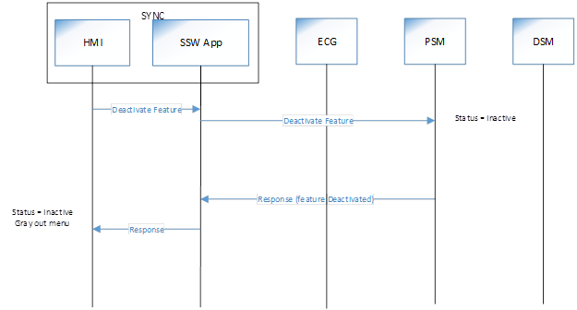

The following message sequence illustrates creating a new setting or modifying an existing setting.



The following message sequence illustrates deploying a defined setting, e.g. work;



The following message sequence illustrates changing the gear position from Park while a non-drive setting is deployed; In this sequence, the vehicle gear will not engage until the setting is back to drive. Sync will display a notification to bring back the steering wheel to drive position.

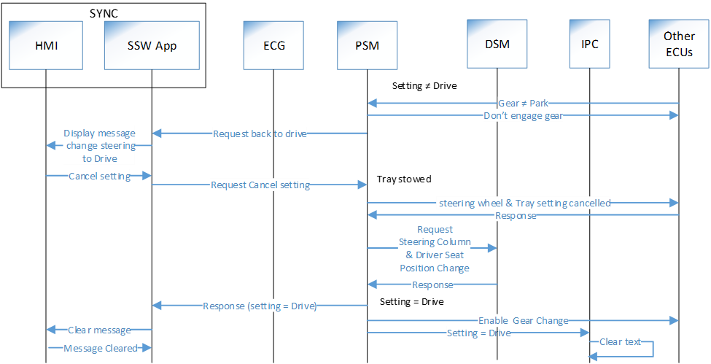

The following message sequence illustrates turning ignition OFF in the middle of deploying a setting

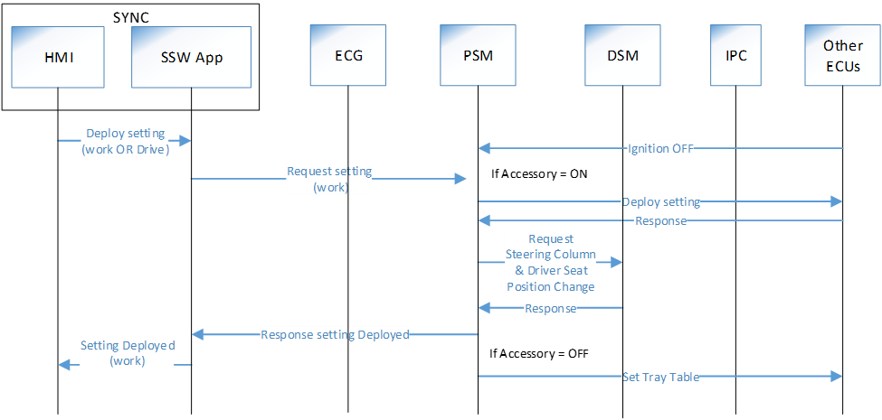

The following message sequence illustrates canceling a setting (attempting to go back to Drive) while deploying the tray table. The command is not executed, and a user notification is displayed to put the tray back and try again.



The following message sequence illustrates deploying a defined setting (work) while tray table is fully opened



## System Functional Requirements

The use of the terms SHALL, MUST, SHOULD and MAY are in accordance with IETF RFC 8174.

Below list is only to provide to the stakeholders a high-level view of the feature requirements and to help the SPSS development as well as the development teams to decompose into derived implementation requirements.

### General system requirements

* If the feature was in a Fault state, the system must clearly indicate that on the HMI
* The feature and settings SHALL survive an ignition cycle.
* The response time from pushing the button to the complete deployment of the setting SHALL not exceed 6 seconds.
* The system SHALL disable the airbag while the feature is in a non drive state.

### FordPass

* NA

### Ford Cloud

* NA

### TCU

* NA

### ECG

* The ECG SHALL maintain a DID for the feature (Supported/not supported).

### SYNC

* Sync SHALL support an application as described in the previous sections.
* Sync SHALL support an HMI application as described in the previous sections.

### IPC

* The IPC SHALL display text according to the feature state once the relevant status message is received.

### PSM Module

* The PSM module SHALL maintain the status of the feature (active/inactive)
* The PSM module SHALL save the tray table parameters for each setting
* The PSM module SHALL handle change requests for tray table
* The PSM module SHALL forward the requests/response to/from the DSM.
* The PSM module SHALL forward driver seat and steering column change requests to the DSM module
* The PSM is aware of the ignition and gear status.

### DSM

* The DSM module SHALL save the steering wheel and driver seat parameters upon request from the SSW App.
* The DSM module SHALL handle change requests for driver seat setting

## Managing potential feature interactions

### Autosave

The feature is used to sense the personal profile to be deployed then order the profile execution based on the saved personal portable profiles.

To prevent a scenario where the two settings (EM & SSW) cancel each other, we must follow this direction;

* Upon deploying any SSW setting, EM SHALL be disabled
  + A user notification such as a popup (grey out the EM menu) must be implemented to notify the user.
  + The user manual must clearly specify the interaction.
  + Moving out of a SSW setting (back to drive setting), the EM feature must be enabled again.

### Power Pitch Feature

The feature allows users move the middle row seat to access the third row. The feature is manually initiated. If there is not enough space, the driver seat may move forward. If the tray table is deployed, the seat movement may result in unwanted outcome.

### Easy exit/entrance

The feature changes the steering and seat positions at vehicle ignition off/door opening and at door opening.

If the command was in the process of being executed and the ignition is turned off/door open, the following table illustrates the expected behavior;

|  |  |  |  |  |
| --- | --- | --- | --- | --- |
| **Feature Setting (Mode)** | | **Component Movement** | | |
| **From** | **To** | **Tray Table** | **Seat** | **Steering wheel** |
| Drive | Work | Continue | Easy Exit/Entrance | Continue |
| Drive | Play | NA | Easy Exit/Entrance | Continue |
| Drive | Rest | NA | Easy Exit/Entrance | Continue |
| Work | Drive | Continue | Easy Exit/Entrance | Easy Exit/Entrance |
| Play | Drive | NA | Easy Exit/Entrance | Easy Exit/Entrance |
| Rest | Drive | NA | Easy Exit/Entrance | Easy Exit/Entrance |

In all other scenarios, the easy exit/entry feature will be executed as is followed by the expected setting; SSW if it was set, an EM setting or to return to the existing setting.

## Impact Analysis Summary on FNV2.0 IVIC Modules

|  |  |
| --- | --- |
| **Module** | **Impact Size** |
| TCU | NA |
| ECG | XS |
| SYNC | M |

# Glossary

|  |  |
| --- | --- |
| **Acronym** | **Definition** |
| APIM | Accessory Protocol Interface Module (SYNC) |
| DID | Data Identifier |
| DSM | Driver Seat Control Module |
| PSM | Passenger Seat Control Module |
| ECG | Enhanced Central Gateway |
| EM | Enhanced memory |
| HMI | Human Machine Interface |
| IPC | Instrument Panel Cluster |
| PPP | Portable Personal Profile |
| SoA | Service Oriented Architecture |
| TCU | Telematics Control Unit |

# References

[1] Stowable steering wheel-power, <https://www.jira.ford.com/browse/INNOTECH-827>

[2] Reductive Memory Switch, PreFeature Document, <https://www.jira.ford.com/browse/INNOTECH-1354>

# Document Reviews

|  |  |  |  |  |
| --- | --- | --- | --- | --- |
| **Name** | **Department** | **Role** | **Email Confirmation** | **Date** |
| Tok Lau |  | Feature Owner |  | 9/2/2020 |
| Tony Deddeh | Global distributed features |  |  |  |
| Ivette Hernandez | HMI | UX center stack |  |  |
| Peter Kung | Vehicle Eng. core | UX translation |  |  |
| Laura Check | IVIC, Sync | Sync |  |  |
| Pre Ps-Team | IVIC, basic design |  |  |  |